The homepage is comprised of 3 components: application bar, dashboard, and footer.

**Accessing The Homepage**

* Please log to: <http://agile.acuitybrandslighting.net/> **agile.acuitybrandslighting.net**. Click accept again after review permissions appears. You can save the url (<http://agile.acuitybrandslighting.net/>) to your favorites for quick access.

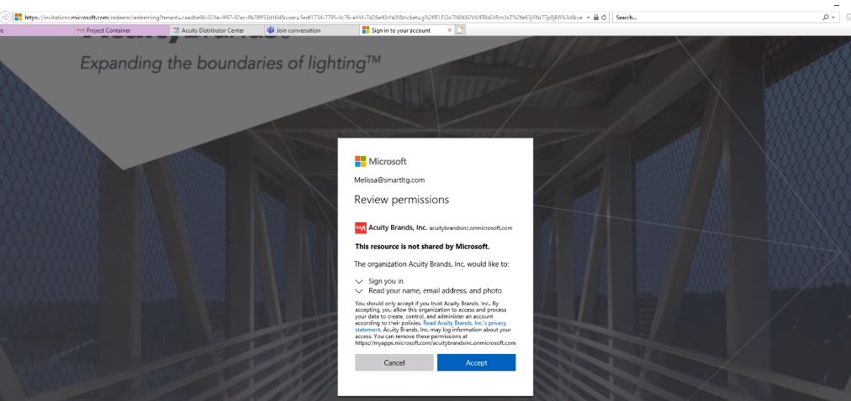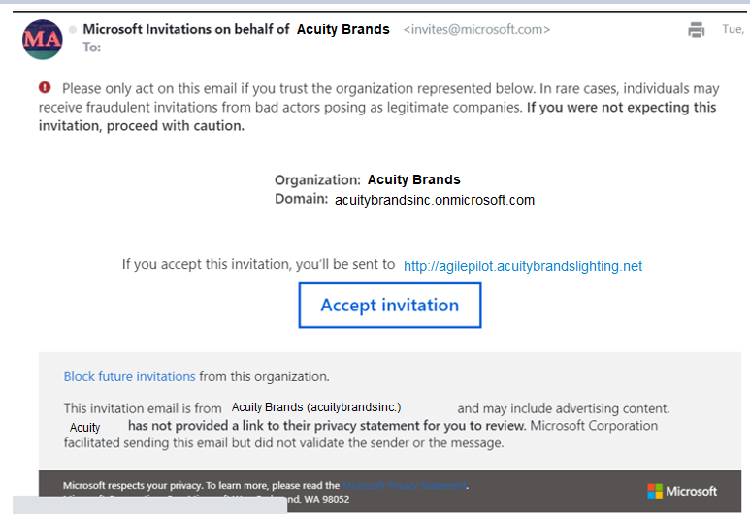

* The Microsoft log in will appear. **Please sign in with your email address** and press next. You will no longer see the Agile secure login screen.

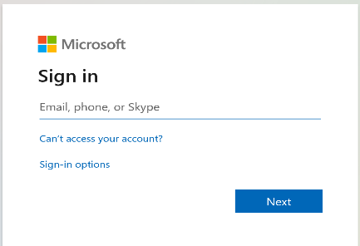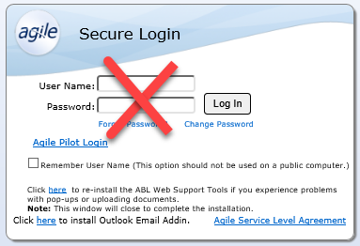

* If your email address has two user ID’s associated to it, you will see both and will select the user you want to log in as and click 

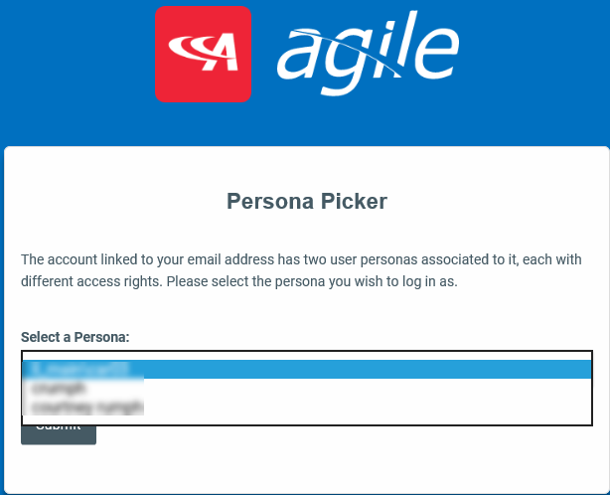

Application Bar

1. Once you are successfully logged in, the homepage will display. First, we will investigate the top blue bar known as the Application Bar. This contains the Tour, Help Menu, agile Blog, User Profile, and Menu.



1. Clicking will display a step by step walkthrough of the new agile homepage. (This does not launch with private browsing in IE).

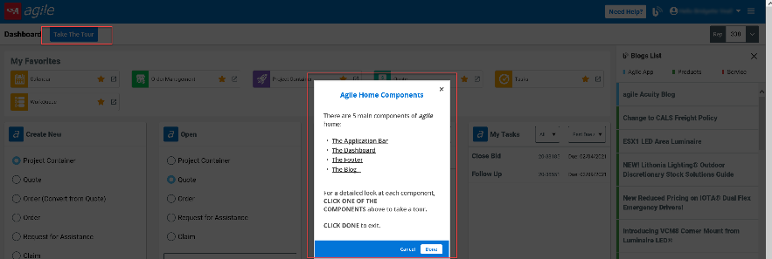

1. The Help documents are accessed by clicking the 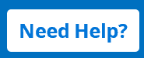 (This does not launch with private browsing in IE).

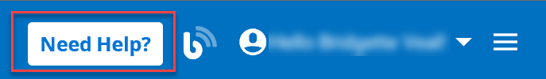 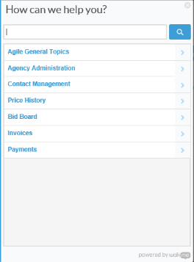

1. The agile blog is accessed by clicking the  in the application bar.

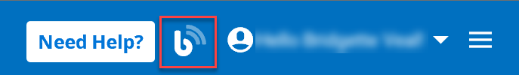 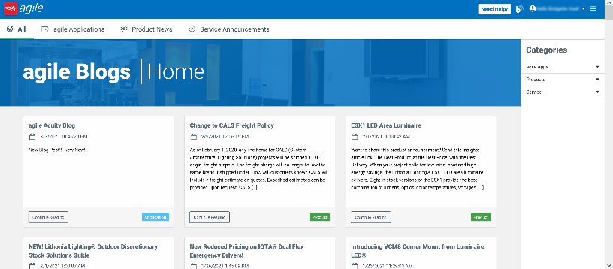

1. The Profile drop down that displays the users name and will also allow the user to log out of their account. If the user needs to change between accounts, they will need to select sign out and then close the browser completely.

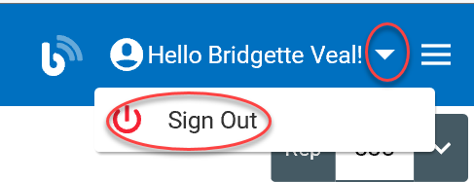

* The hamburger icon below will open the menu. Once the user clicks this icon, it will open the menu and display all the applications the user has assigned to their Agile account.

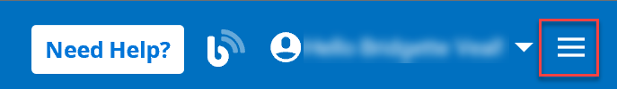 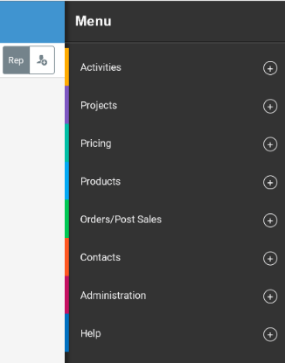

* Clicking the minus icon or anywhere on the application category bar will collapse the section. Clicking outside the menu (hamburger icon) will collapse the entire menu on the home screen.

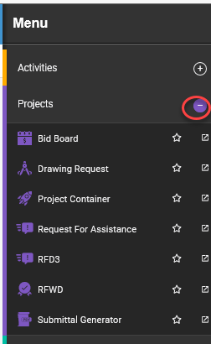 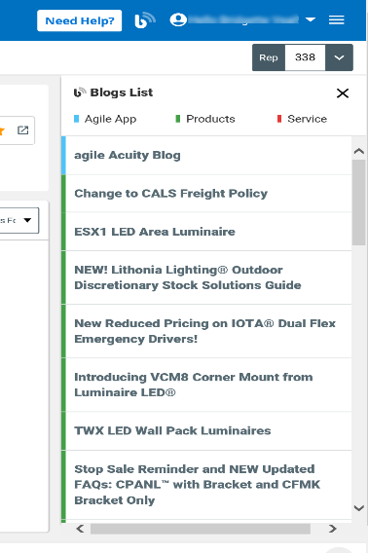

**My Favorite Applications**

1. The user can select the plus icon (or anywhere on the application bar) to open any of the application groups. For example, if the user selects Projects, the dropdown will display all associated applications for their user account. If the user clicks the star, it will pin the app under “My Favorites”. Clicking the star again will remove the app from “My Favorites”. Click on an application name to launch that application inside the Agile Home main screen. If you want to launch the application in a different browser tab, then click on the flyout icon with the arrow.

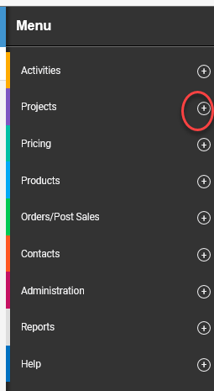 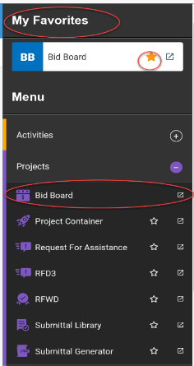

1. You can pin your favorite apps to the top of your homepage dashboard! This is just quick access to your favorite and most used applications to reduce the number of clicks by pinning to your homepage. You can still view apps and your favorites in the hamburger menu. To pin items to the homepage select **Add to Home** in the hamburger menu. You can unpin the apps from the homepage by selecting **Remove from Home**.

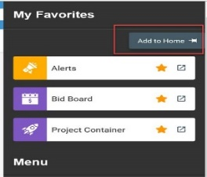 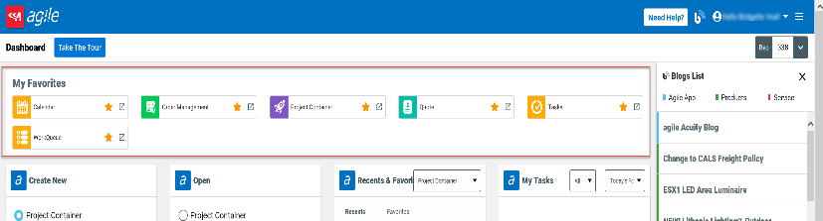

Returning to Agile Home

1. If a user wants to return to the home page dashboard at any time, you can click the Acuity “” or click “” in the upper left-hand corner.

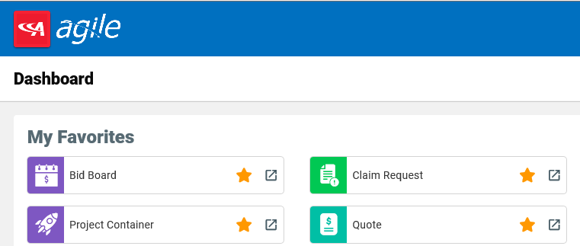

Agile Dashboard

1. Next, we discuss the dashboard. This includes the Rep Selector and Widgets. There are currently four widgets – Create New, Open, Recent & Favorites and My Tasks. These are intended to reduce clicks and save time. For Create New, simply select the application and click Go. For Open, select the application, then type in the number and press enter or Go.

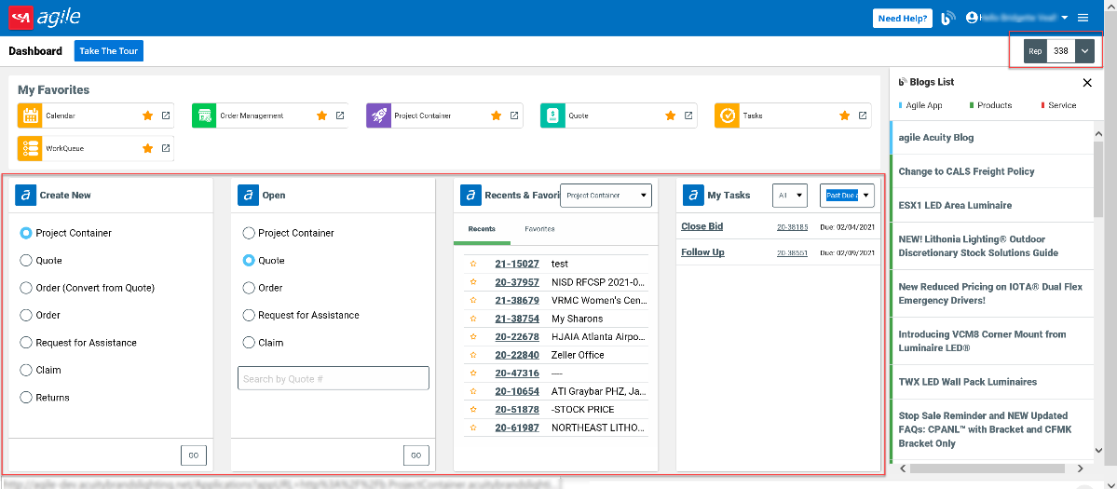

1. For My Tasks allows the user to select from the view dropdown: Today’s follow-ups, Today and next 7 days, Past Due, and Past Due and next 7 days tasks in the My Task widget. You can filter to view all tasks or drop down the application category to Project Container, Quote, or Order. You can click the subject of the task to open the task or you can click on the document number to launch the project, quote or order.

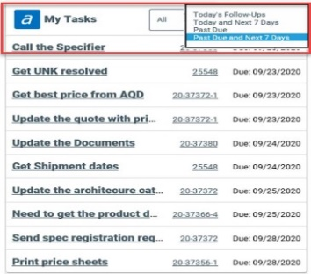 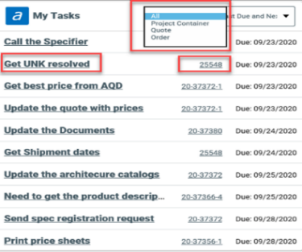

1. The rep selector will allow the user to change reps if the user has more than one allowed rep. Users can type the rep number or name into the search field and click the rep they wish to use. The selected rep will appear under the selected area field. To close out of the rep selector click the X or rep icon.

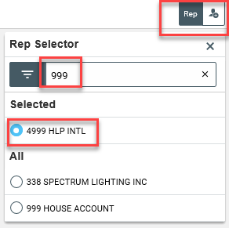

Agile Blog

1. To access the agile blog home you can click on the  in the application bar or the  or under the rep selector to launch the agile blogs home.

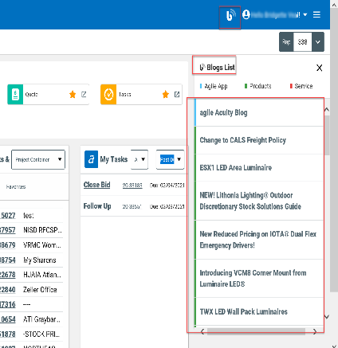 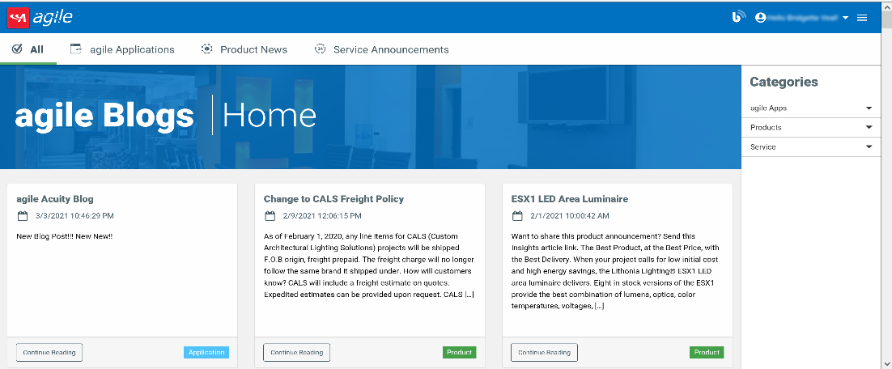

1. You can select any of the blogs in the side panel and it will launch the selected blog:

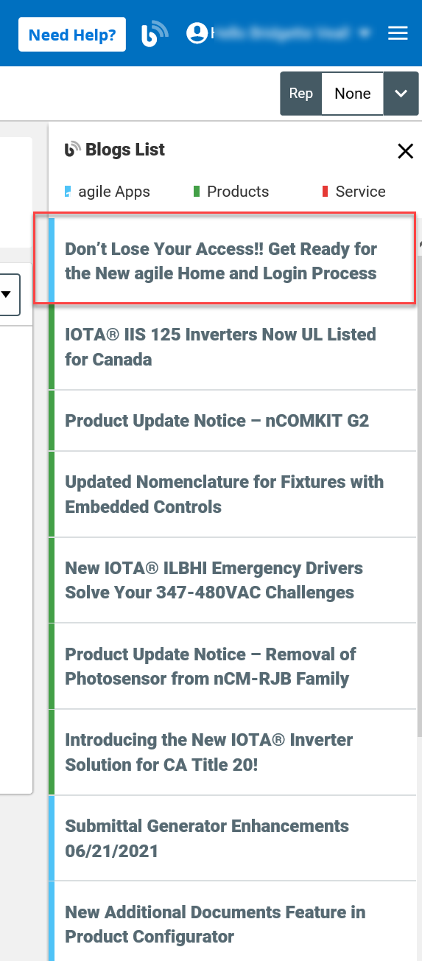 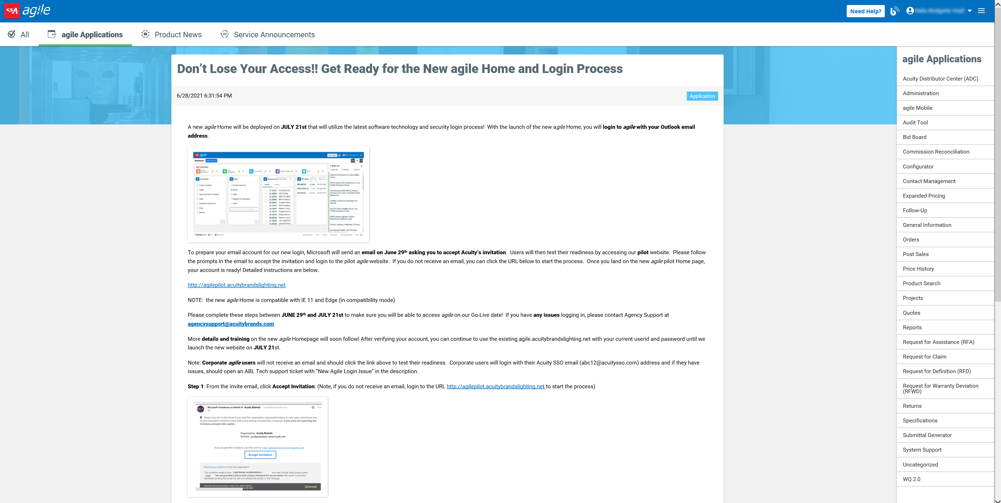

Agile Footer

1. The footer contains great tools and resources. From left to right- the first link will launch the users to Acuitybrands.com.

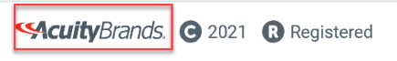

1. Agency support will link you to the agency support site; ADC link will launch Acuity Distribution Center- distributor.acuitybrandslighting.net. Privacy, Do Not Sell and Exercise My Rights launches our policies for these items.



1. The last tool on the footer is the More icon. This is where the Install Tools and Acuity’s social media links are located:

